**Topic 3. Career Path**

**Being a Successful Specialist**

* factors of career success; (p.108)
* hard and soft skills of any successful specialist; (p.109)
* qualities of successful leaders; (p.110)
* typical functions of different department in the organisation; (p.114)
* principles of business ethics and business communication. (p.115-118)

**My Speciality: IT Professional**

* variety of jobs in the sphere of Information Technology; (p.139-140)
* personal qualities of any IT specialist; (p.143)
* typical responsibilities and skills for different IT department jobs; (p.139-140)
* future skills for IT specialists and their importance. (p.145)

**Professional Development**

* Continuous professional development: definition and formats; (p.157-159)
* Cycle of CPD (p.157-159)
* elements of CPD; (p.151)
* the benefits of CPD. (p. 157-159)

Factors of career success

• a private office;

• having a secretary;

• taking holidays when you like; • flying business class;

• a company credit card;

• having fixed working hours.

• big salary;

• your own business; • a company car;

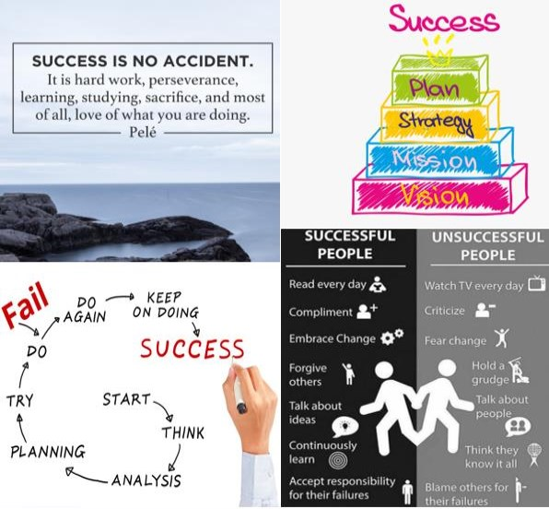a reserved parking space;

• a uniform;

a personal business card;

Hard And Soft skills

Soft skills:

- Management skills

- Team-oriented

- Creativity

- Willingness to learn

- Language proficiency

- Critical thinking

- Problem-solving

- Presentation skills

- Attention to detail

- Communication skills

- Conflict resolution

- Open-mindedness

- Adaptability

- Stress management

Hard skills:

- Project management skills

- Technical skills

- Programming skills

- Marketing skills

- Analytical skills

- Design skills

- Computer skills

- Certificate or degree

Qualities of Successful leader

In general, people appreciate leaders who appear honest and trustworthy. However, **integrity** is a complex idea, often determined by national culture, and what is considered honest in one society is not necessarily so in another.

**Conviction** is a strong belief in what you are doing – is a characteristic of leaders in all cultures. Demonstrating a whole-hearted **commitment** to the success of your team or project is possibly more overt in America than elsewhere.

However, a **passionate** leader with energy and enthusiasm – someone who can energise and inspire their team to succeed – is an asset almost everywhere. Similarly, in most cultures it helps to be a good communicator, to be **people-focused** and have well-developed interpersonal skills.

The ability to make good decisions quickly is something most cultures see as important. However, being **decisive** means different things to different people.

European and Japanese leaders are the most **collaborative** decision-makers, taking time to consult with colleagues and consider the options. This is typical of a more participative style of leadership. In contrast, Chinese leaders, are more likely to make decisions personally. This more autocratic approach tends to be typical of task-oriented, top-down leaders.

Being **adaptable** is also an important quality; team leaders often need to be flexible in their response to changing circumstances. Similarly, the ability to delegate and to know when to be **hands-off** is also necessary.

There’s evidence that **empathy** – ability to understand the feelings of others – is seen as a key to effective leadership in the US and Europe and will become important in Asia as companies have to compete for managerial talent in a global market. Related to this, certain Asian cultures value leaders who are **self-aware** and **humble**.

 typical functions of different department in the organisation;

Administration: b) Formalising contracts, managing social insurance and vacation permits. e) Organisation, planning, direction, coordination, control, and evaluation of other departments' activities.

Human Resources: Not directly mentioned in the given descriptions.

Finance: h) Acquiring funds for the firm, managing the company's cash flow, managing taxes.

Information Technology: d) Developing, managing, and maintaining an organization's technology-related assets, policies, procedures, and systems.

Production and Quality Assurance: g) Manufacturing goods for the business, preventing mistakes and defects in manufactured products, and avoiding problems when delivering products or services to customers.

Supply Chain Management: a) Managing operations involved in procurement, processing raw materials into finished goods, and distributing to the end consumer.

Marketing: c) Promoting the business and mission of an organization, monitoring and managing social media.

Customer Service: f) Creating a trustworthy atmosphere and providing the client with the exact information they need right at the time when they want it.

principles of business ethics and business communication.

***Situation 1. An accounting dilemma***

You work in accounts. While checking the company accounts one day, you discover that your financial director has been claiming irregular expenses. The expenses include four opera tickets, two digital cameras and a laptop computer which you think he bought for his daughter. Some of the expenses have already been paid to him, but not all. What would you do?

***Situation 2. A generous present***

One of your suppliers sends you an unexpected present: a case of twelve bottles of expensive wine. The following week, they call you to ask if you have received the wine and whether the company is going to renew their contract for the next year. You tell them the decision has not been made yet, and they intimate that if you renewed their contract, they would give you more presents, including a weekend away for two. You have already drunk three of the bottles during family meals. What would you do?

***Situation 3. Choosing tenders***

Your company is going to build new offices in Algeria, and you are responsible for examining tenders for all the contractors interested in building the new office. The two best tenders are of equal merit, and you were intending to recommend them both and let the Board of Directors decide. This morning, over coffee with your managing director, he mentions that he is very good friends with one of the two contractors on the shortlist and would be very disappointed if they did not win the contract. What would you do?

**Start using the right tools for your business**. Fortunately, tools like ProofHub, Slack, Zoom can help you to boost company communication providing a total seamless communication experience.

- **Encourage two-way communication**. Encourage your employees to ask questions or voice their opinions helping them feel empowered.

- **Tell people what they are doing right**. It is a good idea to tell people about their good things on a daily basis.

- **Specific and descriptive feedback.** Give feedback that is concrete. Give directions to the person exactly on what they are doing well and what needs to be improved.

- **Schedule a compulsory check-in**. Organising a short quick call with a very specific agenda brings in a lot of advantages.

117

- **Organise engaging team building activities**. According to a 2019 report by Gallup, companies with engaged workers generally earn three-times more revenue. Team building activities enhance productivity and engagement

variety of jobs in the sphere of Information Technology

Hardware engineers

design and build computer systems. They combine expertise in technology, electronics and engineering. They also develop individual components for computer systems, including microchips, processors and circuit boards, as well as computing peripherals

Systems analysts

manage IT solutions to drive business goals. These professionals analyse an organisation’s current computer systems and procedures and recommend strategic changes to increase productivity and reduce costs

Video game developers

merge creativity, technical skills and a passion for gaming to create cutting-edge games. They always have a desire to learn the latest programming, art and media production skills

IT security specialists

defend an organisation’s Information Systems. These specialists are competent at cyber security threats, technologies and countermeasures to ensure secure computer systems. This often includes tasks like installing and configuring security software, educating employees on data security, monitoring and protecting against network breaches

Mobile application developers

create software for mobile devices. They write programs inside of a mobile development environment using programming languages

Graphic designers

use creativity and technology to create visually engaging graphics that communicate a message. Their duties are designing web pages, laying out catalogues and newsletters, designing logos

Database administrators

organise and manage a company’sdata. They ensure that business data is accurate, available and secure

Network specialists

analyse, troubleshoot and evaluate computer network problems. They are responsible for building and designing communication networks, maintaining an organisation’s network and keeping them safe and secure

Web developers

create web pages and web-based applications. Their workflow includes collecting or creating web content planning web site layout and navigation, coding the actual web pages, then testing and optimising the website

Computer programmers

write the code that fuels computer operation. They translate project specifications into a script of logical instructions that computers can understand and interpret into functioning programs

Software engineers

develop computer systems and applications. They design, develop and improve upon the computer programswe use everyday, including business apps, operating systems, network control systems, and social networks

IT help desk technicians

keep the technologies that organisations rely on to do business up-to-date and running smoothly and provide technical support and troubleshooting services to end-users who need assistance with their computer hardware or software

personal qualities of any IT specialist

Detail-oriented

Responsible

Honest

Curious

Intelligent

Conscientious

Confident

Quality-oriented

Studious

Communicative

Hard-working

Motivated

typical responsibilities and skills for different IT department jobs

future skills for IT specialists and their importance

**Emotional intelligence**

Most people can pass a certification exam or learn a new software application. But not everyone has an ability **to lead a team** through a tough project, build relationships with stakeholders, or keep a remote team engaged. Employees should place more emphasis on being able **to deal with conflicts**, manage a virtual team and deliver on strategy **to achieve tangible benefits** for the business. We can call themsoft skills or **emotional intelligence** – employers are going to seek out this attribute more and more.

**Adaptability**

Because of **technological advances**, shifts in society, and the many unknowns of the future, project managers need to be open to new ideas, flexible **to pivot with changing times**, and ready to adapt to changes.

**Working with and managing remote teams**

Working remotely and with dispersed, international teams is on the rise, and employers will be looking for IT specialists who have experience successfully working from home, as well as managing a remote team.

Hiring managers at remote companies are looking for candidates who can communicate verbally and in writing, have **an independent**

**streak**, and have a track record of successfully managing their own projects.

**Data science expertise**

The Internet of things, automation, and artificial intelligence have been the buzzwords since 2017. These advances are going **to shake up** every industry in some way. **IT management** is definitely getting a pass on this one.

For IT professionals, this means that our programs, systems are going to start talking to you. They’ll help you to identify risks, detect problems, and unload the administrative tasks through automation. So, there will be an increased need for project managers with big **data expertise**.

**Professional Development**

Continuous professional development: definition and formats

Continuing Professional Development (CPD) is a process of building, maintaining and enhancing your knowledge and skills. CPD helps you to plan your development, review what you have learnt and evaluate the effectiveness of your activity. Your commitment to CPD is important as the activities you choose will help to **underpin your validity** and competence as a professional

Cycle of CPD

Any professional must take ownership of their career and development. The Continuous Professional Development Cycle includes the following steps: identifying your development needs through planning and then carrying out your learning activities, **reflecting on** your learning and then applying it and sharing it with others. It can also be as simple as asking yourself these three questions:

Elements Of CPD

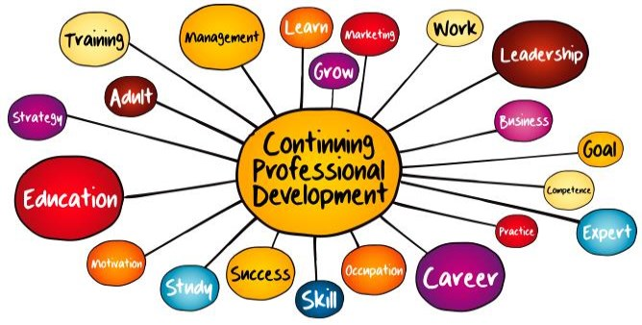

Benefits Of CPD

Other potential benefits are as follows:

increased job satisfaction and morale among employees; increased employee

motivation; increased efficiencies in processes, resulting in financial gain; increased capacityto adopt newtechnologies and methods; increased innovation in strategies and products; reduced employee turnover; enhanced company image, e.g., building a reputation as a “great place to work”. Training provides greater skill and knowledge to employees, which, actually, leads to better job performance.